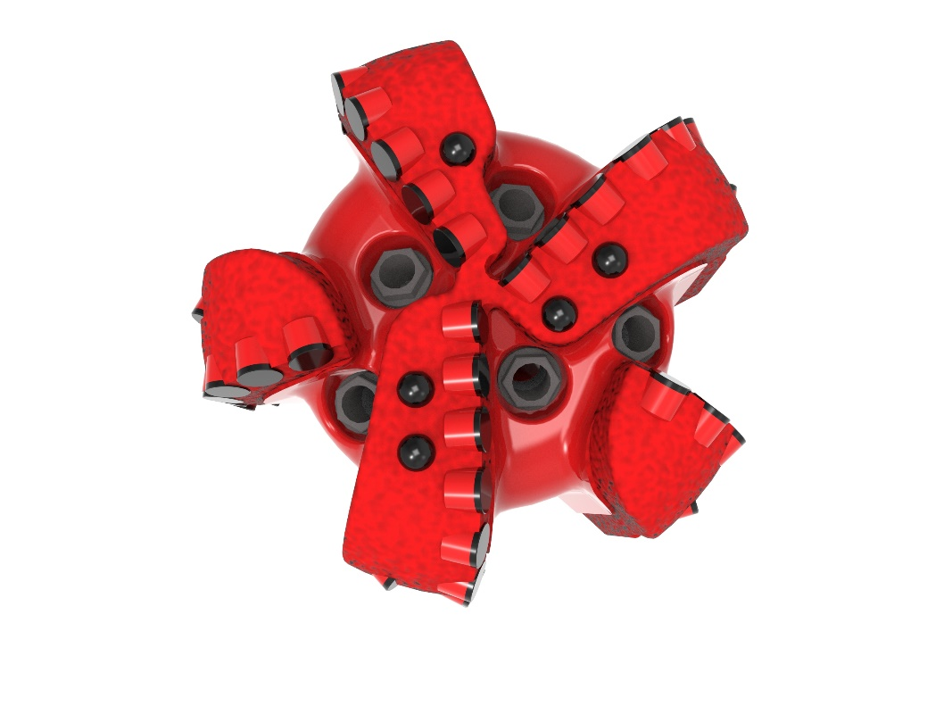
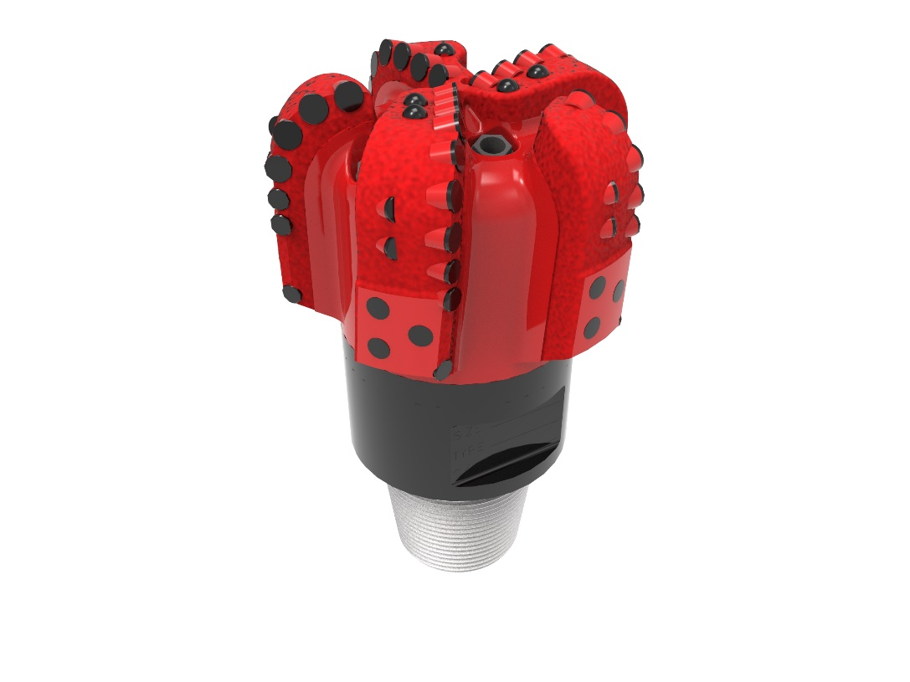

Drill Bit Specifications:
Cutter Size (Primary, Secondary) | 5/8”, 1/2”
Cutter Count (Total, Gage, Back Reaming) | 51, 10, 5
Blade Count | 5
Gage Length (Inches) | 2.00
Nozzle Count (Primary, Sec.) | 5
Nozzle Series (Primary, Sec.) | 60
JSA (Sq. Inches) | 17.57
Max. TFA (Sq. Inches) | 1.86
Operating Parameters:
Max. Weight on Bit (1,000 Lbs.) | 60
Make-up Torque (ft/lbs) | 16,488
Nominal Dimensions:
Overall Length (Inches) | 14.22
Make Up Length (Inches) | 10.10
Bit Breaker | SKB-21010
Connection | Ø4-1/2" API Reg.
Approx. Weight (Lbs.) | 98

Standard Features:

- Premium grade cutters maximize ROP and Life
- Nozzle configuration and large open face volume optimize blade cleaning and cuttings removal

516-SR+(K)(BR) Nomenclature Explained:

• | 5 | = | Number of blades
• | 16 | = | Primary Cutter Size (16mm)
• | SR+ | = | Partial Backup Row of Cutters
• | K | = | Bullets
• | BR | = | Back Reamers


